ApexPlanet Software Pvt. Ltd.
INTERNSHIP TASK REPORT
Network Security & Scanning
Domain: Cybersecurity & Ethical Hacking
Submitted by: Akshat Arin Mazumdar
College: Indore Institute of Science and Technology
Degree: B.Tech
Date: 23 September 2026

1. Objective
The objective of this task was to gain hands-on, practical exposure to core network security and vulnerability scanning techniques used in real-world cybersecurity assessments. This involved setting up and operating industry-standard tools to discover live hosts and open services, capture and analyse network traffic, identify vulnerabilities using an automated scanner, simulate network stress/flood conditions in a controlled manner, and enumerate web application directories to understand the exposed attack surface of a target system. The exercise was aimed at strengthening the practical understanding of reconnaissance, scanning, and monitoring phases that form the foundation of ethical hacking and penetration testing workflows.

2. Tools Used
Tool | Purpose in this Task
Nmap | Network scanning tool used for host discovery, open port identification, service/version detection, and OS fingerprinting.
Wireshark | Packet capture and protocol analysis tool used to record and inspect live network traffic on wireless and Ethernet interfaces.
OpenVAS / GVM | Greenbone Vulnerability Management suite used to perform automated vulnerability assessment against the target host.
hping3 | Command-line packet crafting tool used to simulate SYN-based traffic and test port responsiveness under a controlled flood scenario.
Gobuster | Directory/file brute-forcing tool used to enumerate hidden or unlisted paths and endpoints on a target web server.
iptables | Linux firewall utility referenced for configuring host-based packet filtering rules to control and restrict inbound/outbound traffic.

3. Methodology

3.1 Network & Host Reconnaissance
- Performed a TCP SYN scan (nmap -sS) on the target host to identify open ports without completing the full TCP handshake.
- Executed OS fingerprinting (nmap -O) to determine the operating system and device type of the target.
- Ran a service/version detection scan and a UDP scan (-sU) to gather deeper service-level information.
- Used nc -v and nslookup to independently verify port reachability and DNS resolution.

3.2 Vulnerability Assessment with OpenVAS/GVM
- Installed the Greenbone Vulnerability Management (GVM) stack including gvmd, gsad, ospd-openvas, and gvm-tools.
- Created and configured an administrative GVM user account and reset credentials where required.
- Synchronised vulnerability feed data (NVT, SCAP, CERT) and resolved feed-lock and service-startup issues.
- Validated the installation using gvm-check-setup and started the GVM services (gvmd, gsad, ospd-openvas).

3.3 Traffic Capture and Analysis with Wireshark
- Captured live traffic on the wlan0, eth0, and loopback interfaces during scanning activity.
- Saved capture sessions as .pcapng files for later inspection of packet-level behaviour.

3.4 Controlled Flood Simulation with hping3
- Verified hping3 installation and crafted raw SYN packets toward the target host.
- Executed a flood-mode SYN test on port 80 to observe traffic generation at scale in a controlled lab environment.
- Sent targeted SYN probes to ports 22 and 80 individually to record RTT and response-flag statistics.

3.5 Web Directory Enumeration with Gobuster
- Reviewed the Gobuster help menu to understand available enumeration modes (dir, vhost, dns, fuzz).
- Corrected initial command-syntax and wordlist-path errors encountered during setup.
- Executed a directory enumeration scan using the dirb common.txt wordlist against the target domain.
- Filtered results for security-sensitive keywords (admin, config, password, api, backup) and verified select endpoints with curl.

4. Findings / Results
The following screenshots document the practical execution of each phase described above, captured directly from the terminal during the task.
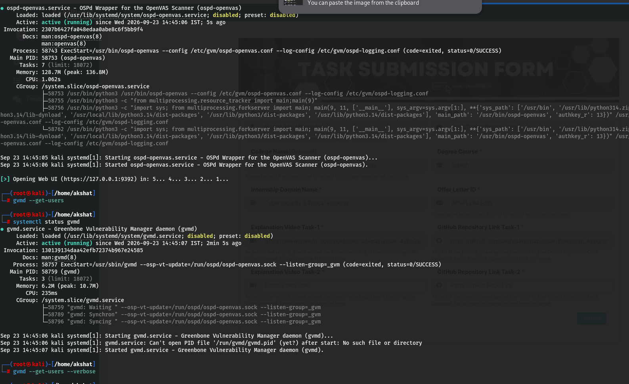
Figure 1: OSPd-OpenVAS and GVMD Service Status
Output of systemctl status for ospd-openvas.service and gvmd.service, confirming that the OpenVAS scanner wrapper and the Greenbone Vulnerability Manager daemon were successfully started and are in the active (running) state, along with the gvmd --get-users command used to verify configured GVM users.
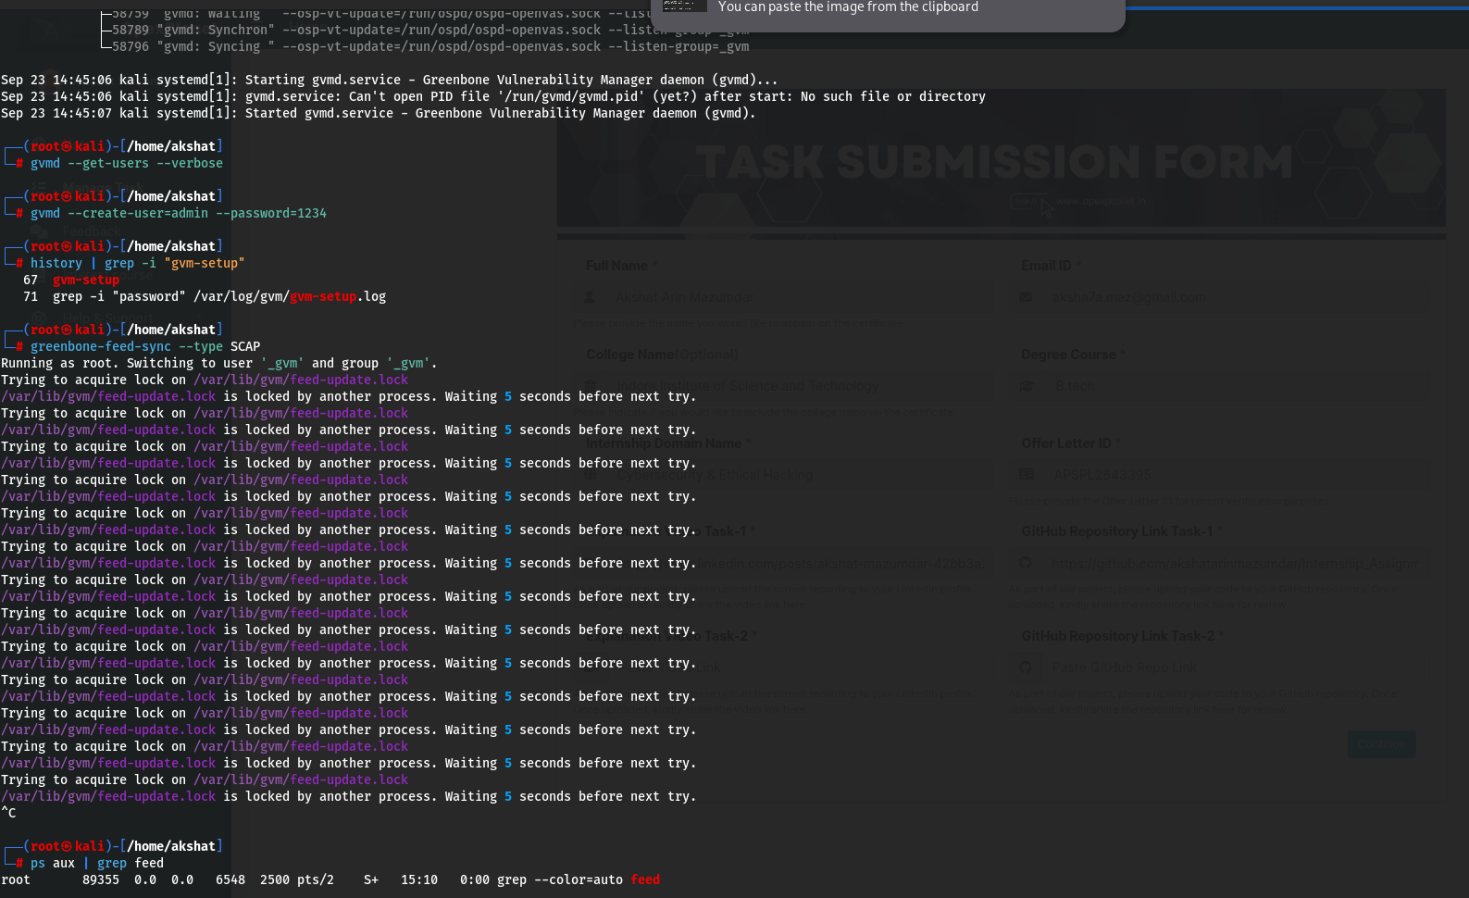
Figure 2: GVM User Creation and Feed Synchronisation Attempt
Creation of an administrative GVM user (gvmd --create-user=admin) and an initial attempt to run greenbone-feed-sync to update SCAP vulnerability data. The feed-update.lock file was held by another background process, so the sync repeatedly waited before retrying.
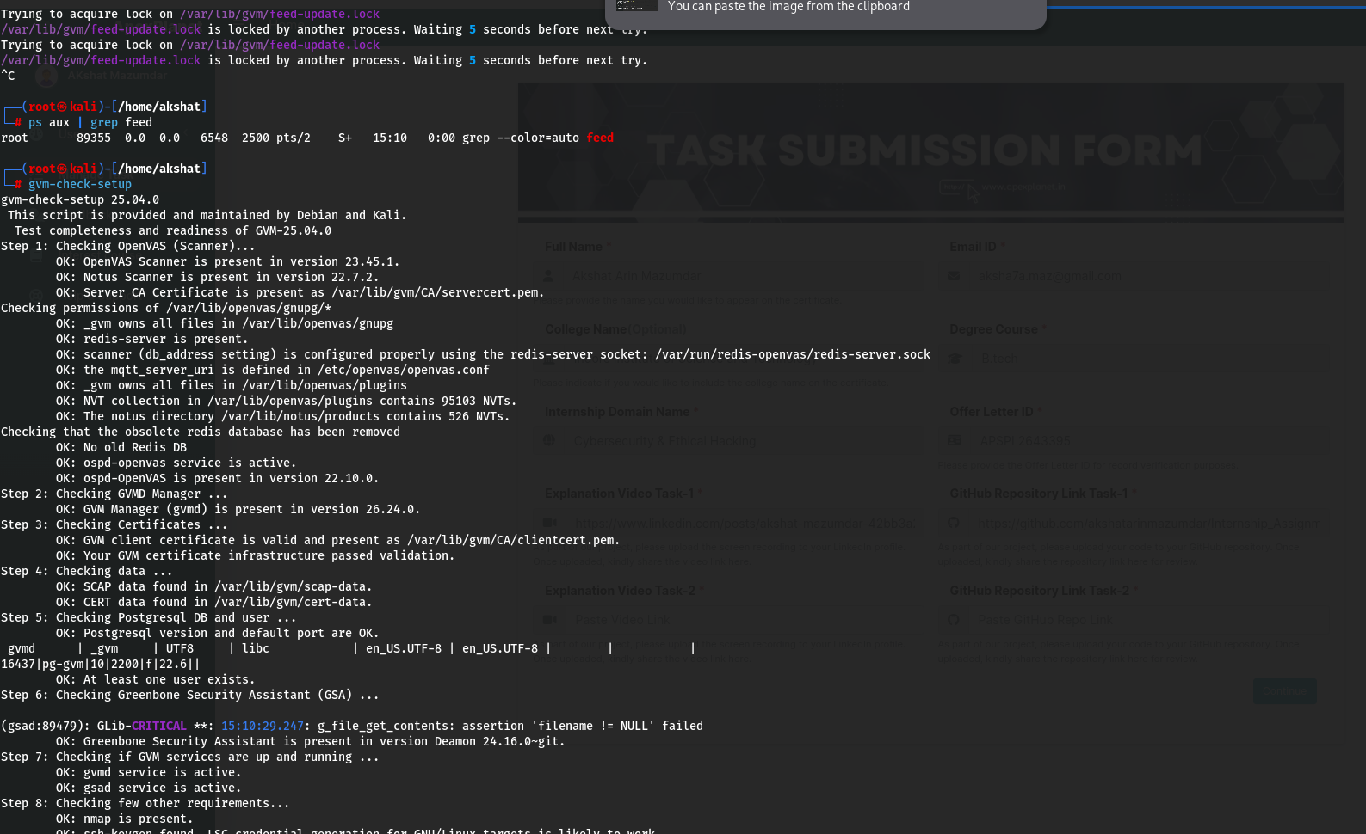
Figure 3: Feed Lock Retry and GVM Setup Verification (Part 1)
Continuation of the feed-update lock retry loop, followed by the gvm-check-setup diagnostic utility, which validates the OpenVAS scanner, NVT/Notus data, certificates, and database configuration to confirm the installation is healthy.
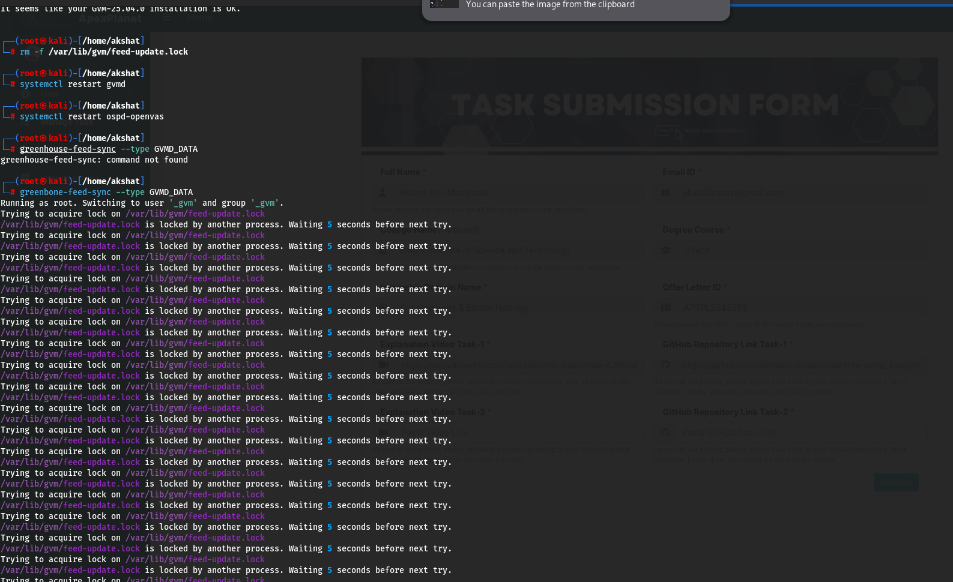
Figure 4: Manual Lock Removal and Service Restart
The stale feed-update.lock file was manually removed and the gvmd and ospd-openvas services were restarted to clear the blocked state before re-attempting the GVMD data feed synchronisation.
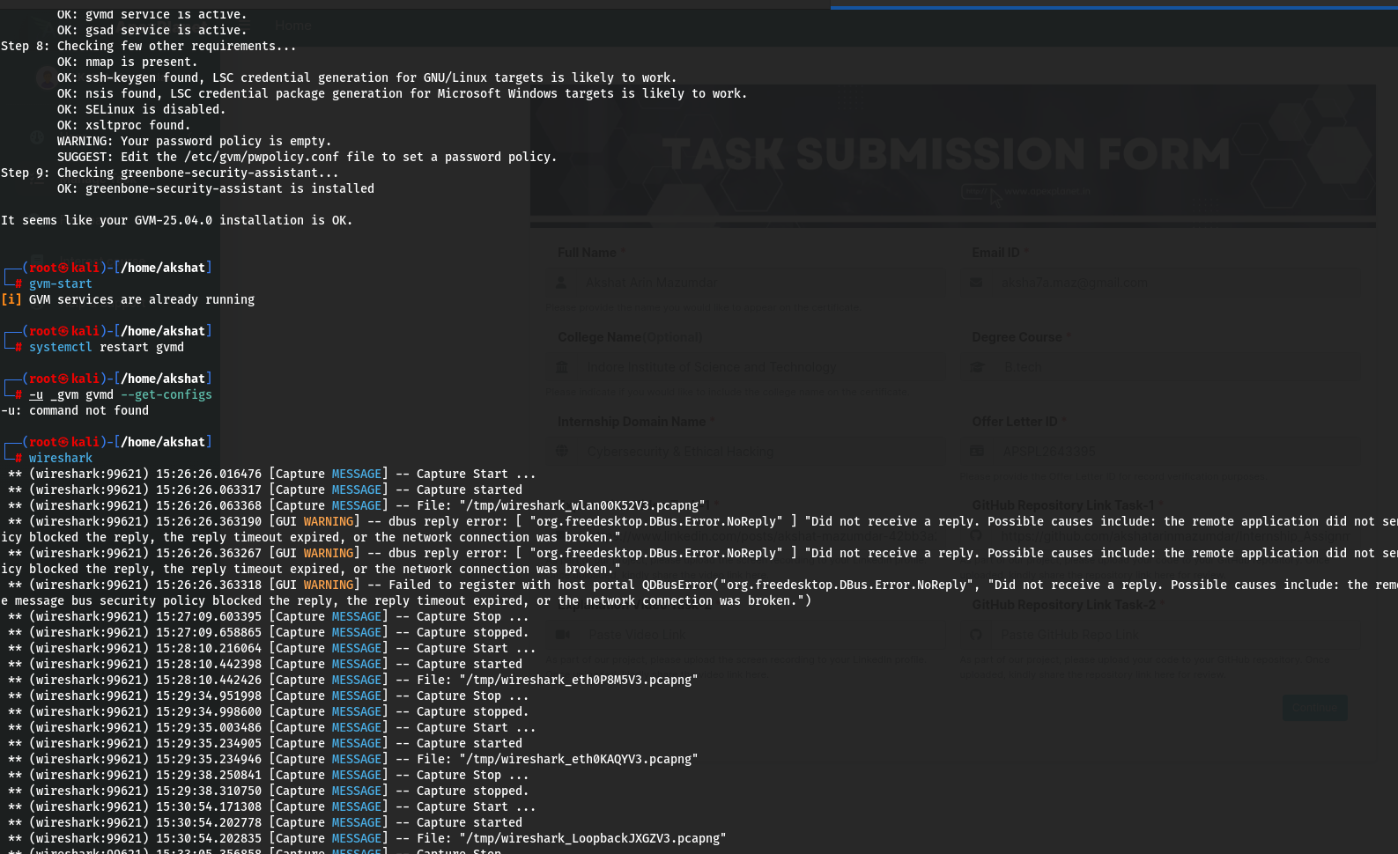
Figure 5: GVM Setup Completion and Wireshark Capture Start
Final steps of gvm-check-setup confirming a healthy GVM-25.04.0 installation ('installation is OK'), followed by starting the GVM web services (gvm-start) and launching Wireshark to begin capturing live traffic on the wlan0 and eth0 interfaces.
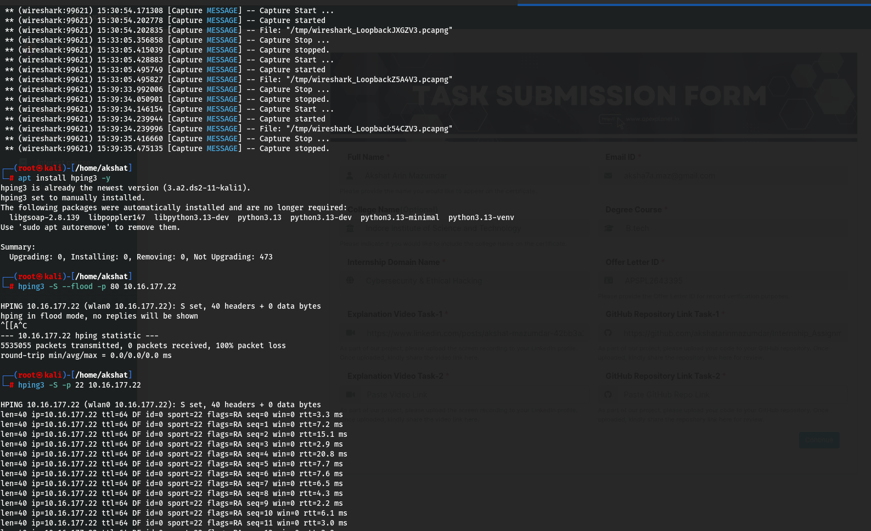
Figure 6: Wireshark Loopback Capture and hping3 SYN Flood Test
Wireshark capture logs for the loopback interface, followed by verification that hping3 was installed and a controlled SYN flood simulation launched against the target host (10.16.177.22) on port 80 in flood mode to observe network behaviour under high packet-rate conditions.
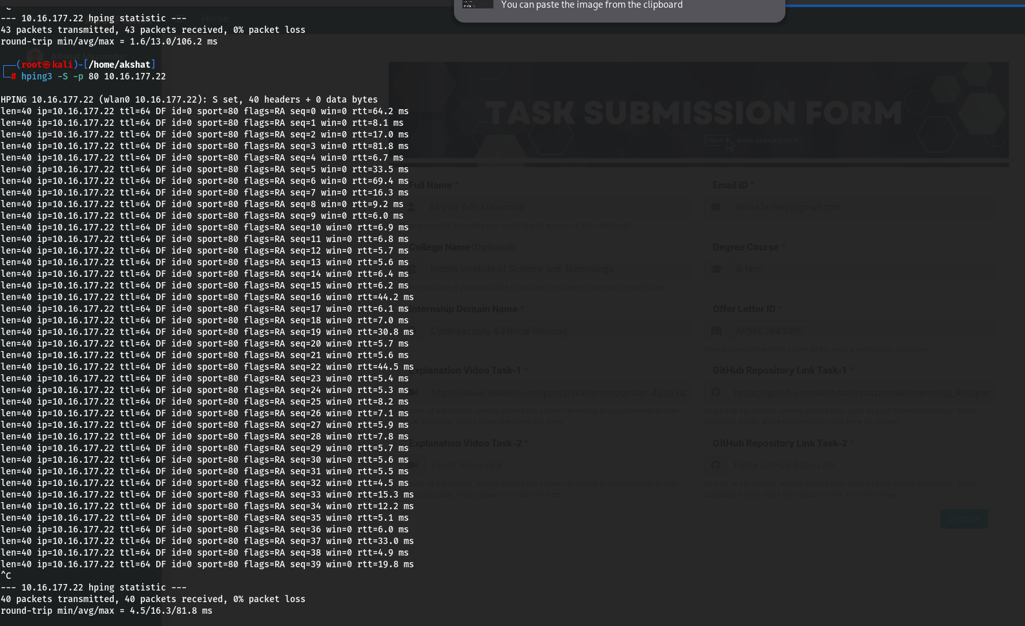
Figure 7: hping3 Targeted Port Probing (SSH and HTTP)
Controlled hping3 SYN probes sent to port 22 (SSH) and port 80 (HTTP) on the target host, capturing response flags (RA - Reset/Ack) and round-trip time statistics, which help assess port responsiveness and basic network latency.
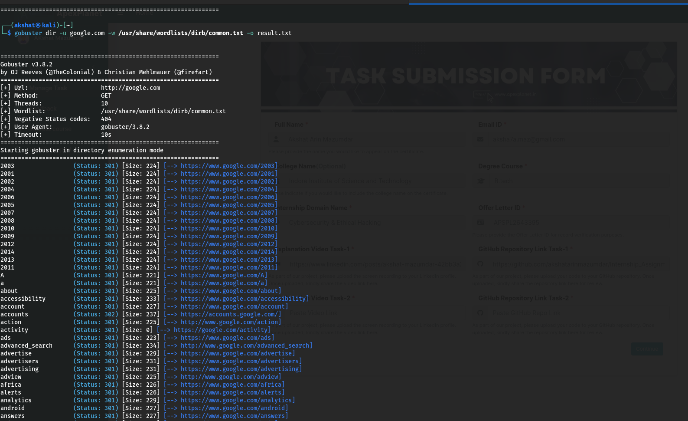
Figure 8: Gobuster Directory Enumeration - Scan Initialisation
Gobuster launched in directory enumeration mode against google.com using the dirb common.txt wordlist, showing the scan configuration (threads, negative status codes, user agent) and the first set of discovered paths with their HTTP status codes and redirect targets.
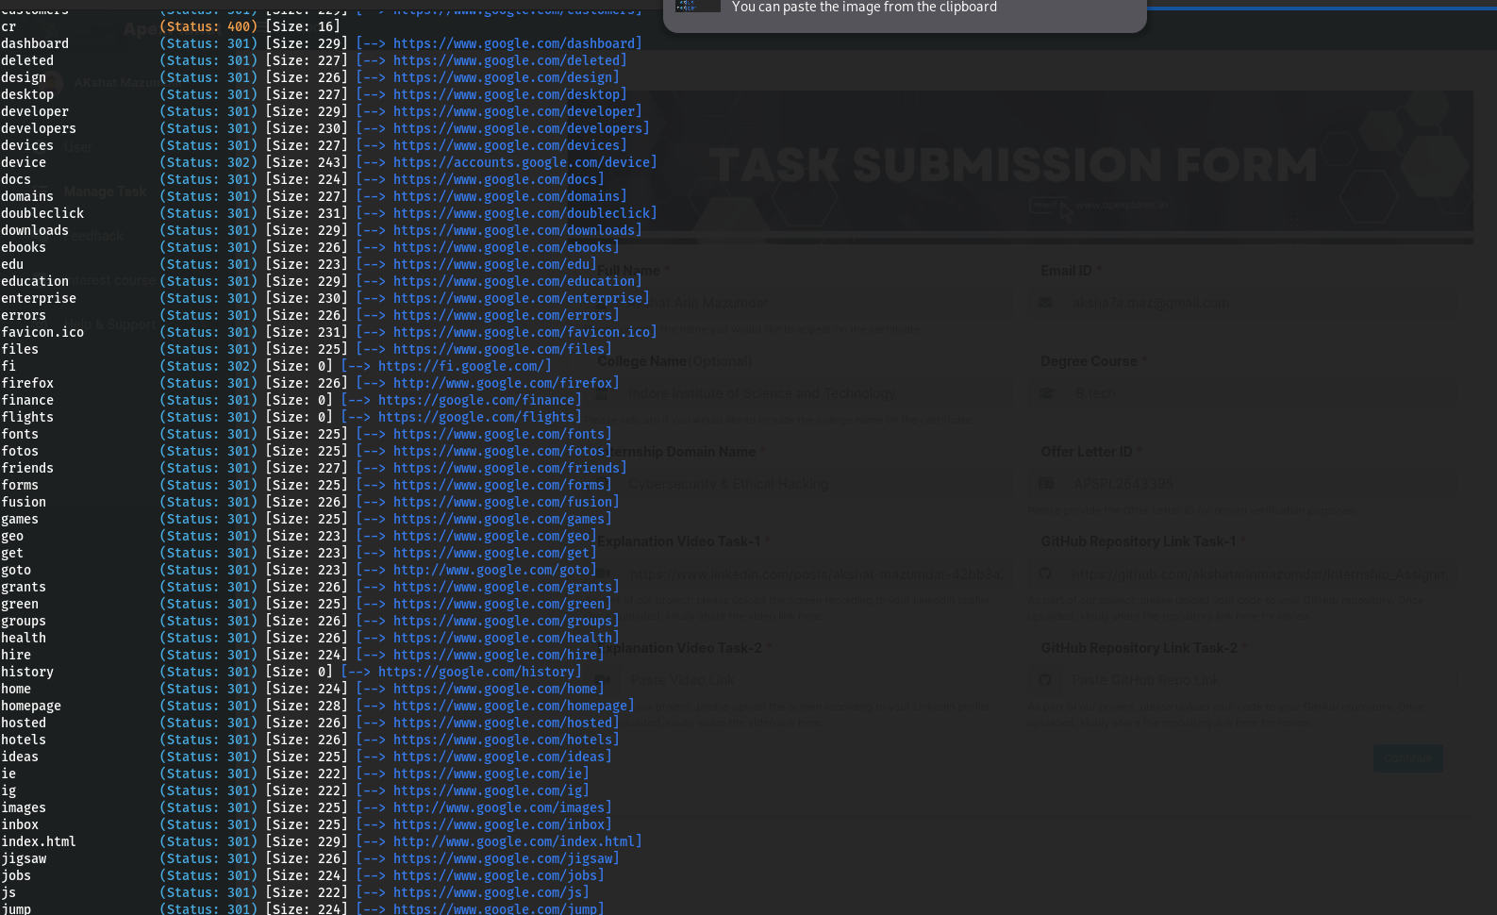
Figure 9: Gobuster Directory Enumeration - Discovered Paths
Continued Gobuster results listing additional discovered directories/endpoints such as dashboard, developer, devices, docs, and favicon.ico, each with their corresponding HTTP status code and size, useful for mapping the attack surface of a web application.
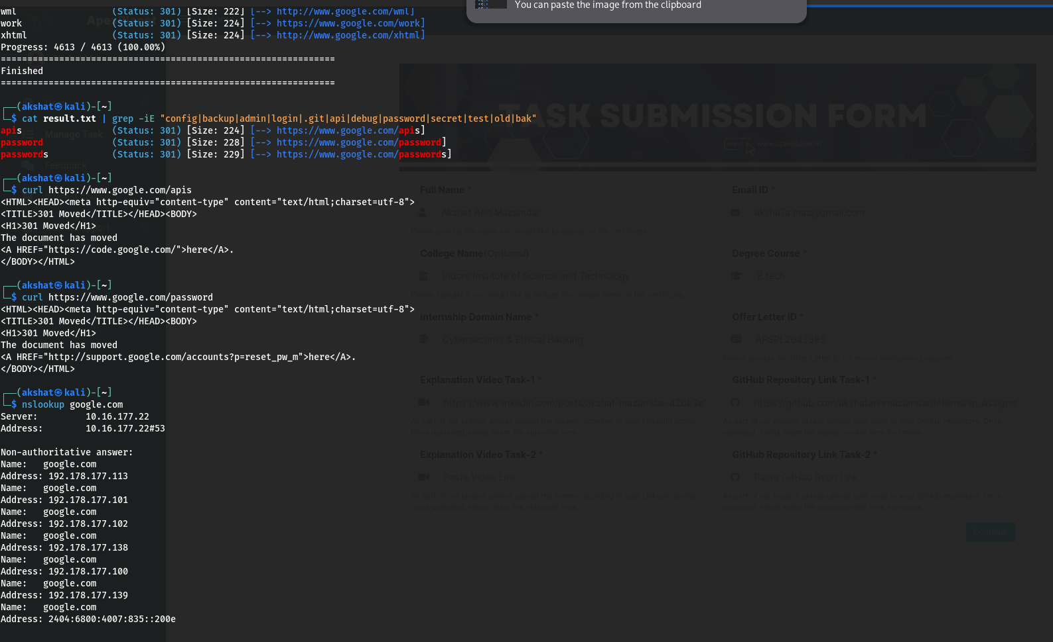
Figure 10: Filtering Results and DNS/HTTP Verification
Completed Gobuster scan filtered with grep for sensitive keywords (config, admin, password, api, etc.), followed by curl requests to verify the discovered 'apis' and 'password' endpoints, and an nslookup query resolving google.com to its IP addresses.
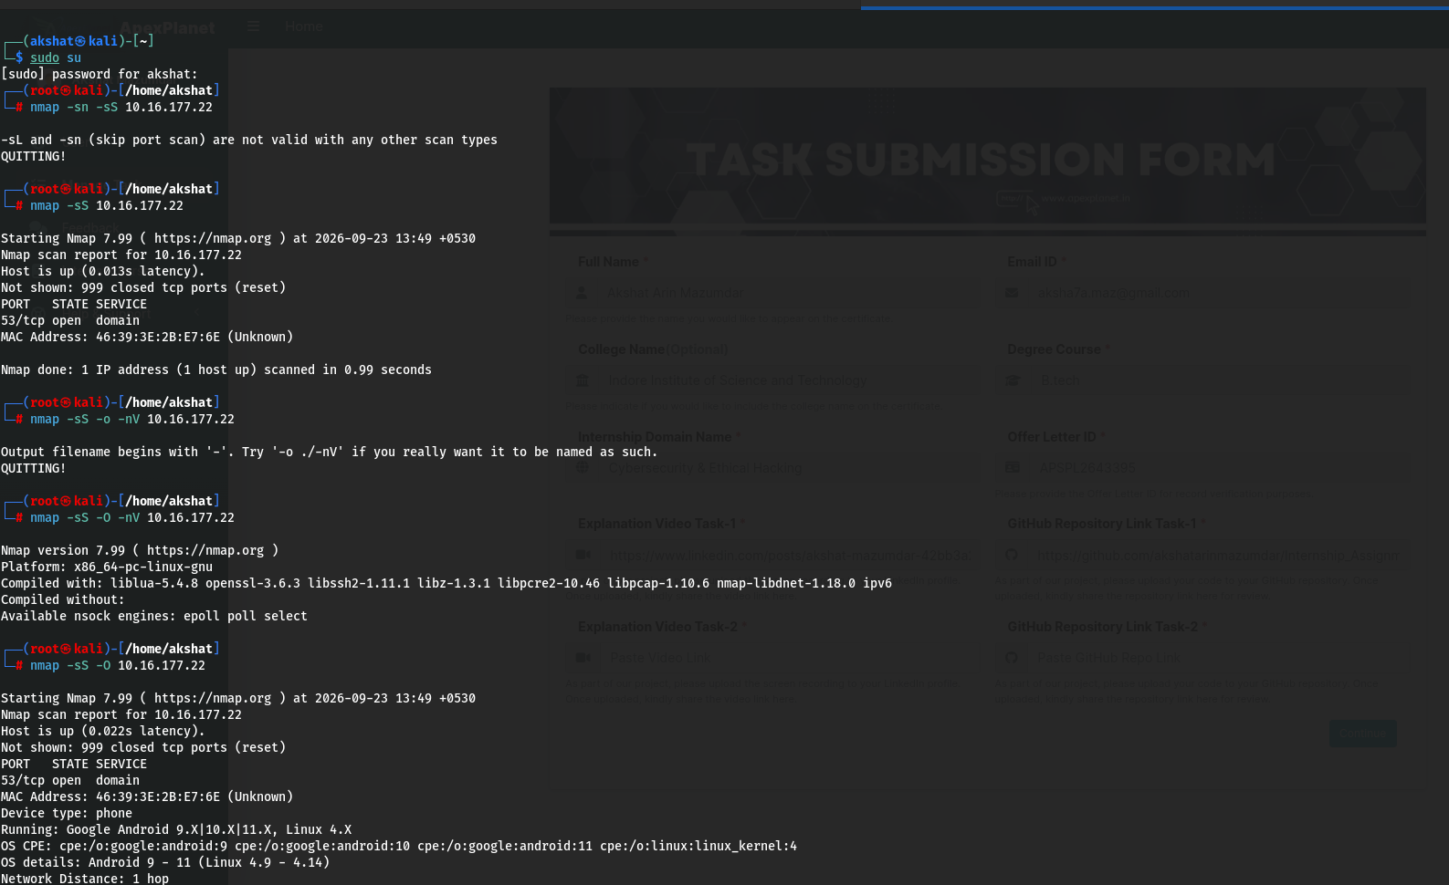
Figure 11: Nmap SYN Scan and OS Fingerprinting
Nmap SYN scan (-sS) against the target host revealing an open DNS port (53/tcp), followed by an OS detection scan (-O) that fingerprinted the device as an Android-based host, illustrating how Nmap can reveal both open services and underlying device details.
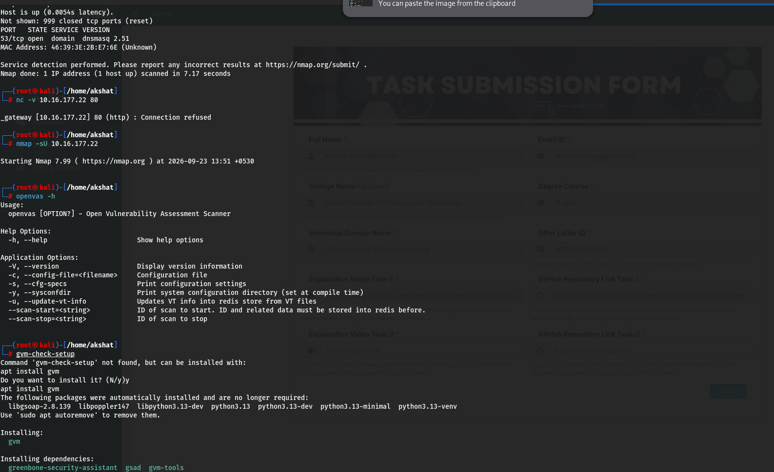
Figure 12: Service Detection, UDP Scan, and OpenVAS/GVM Preparation
Nmap service/version detection identifying dnsmasq 2.51 on port 53, a refused Netcat connection test on port 80, initiation of a UDP scan (-sU), the OpenVAS CLI help menu, and the beginning of the GVM package installation process required for vulnerability scanning.
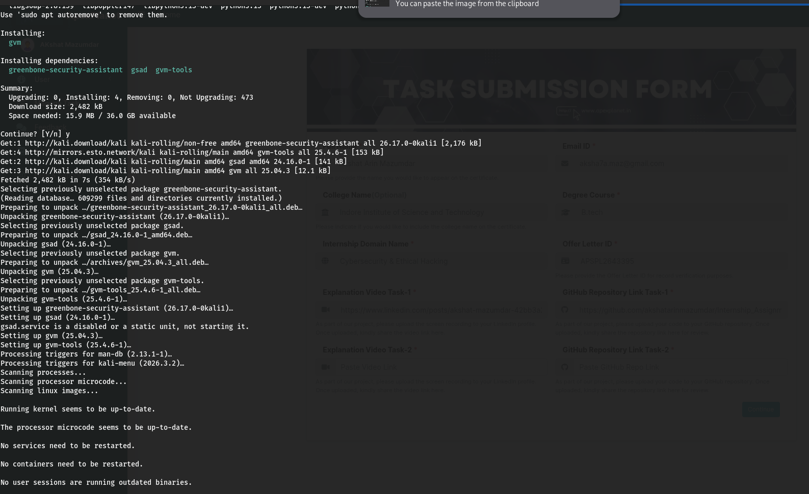
Figure 13: GVM Package Installation Summary
APT package manager output showing the successful installation of the Greenbone Vulnerability Management stack - greenbone-security-assistant, gsad, gvm, and gvm-tools - which together provide the scanning engine and web interface for vulnerability assessment.
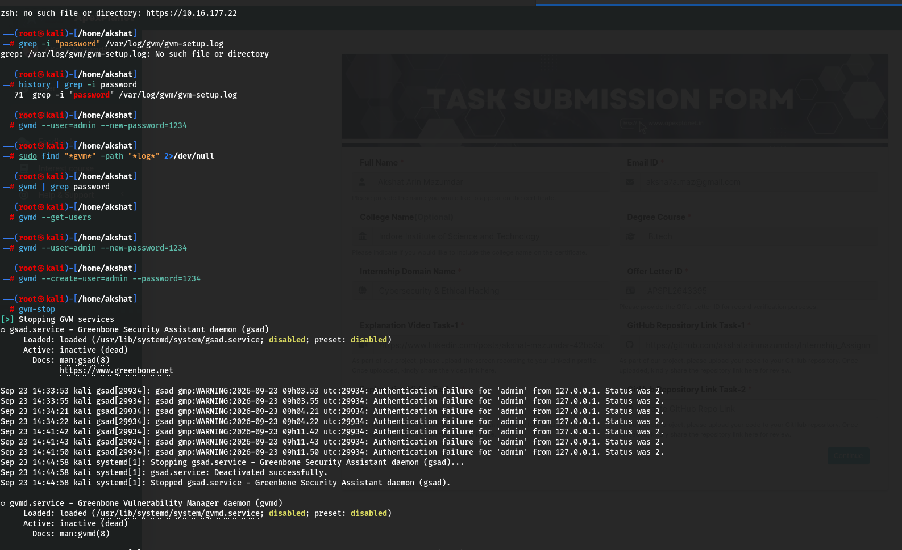
Figure 14: GVM Password Reset and Service Shutdown Logs
Resetting the GVM administrator password (gvmd --user=admin --new-password), followed by the gvm-stop command and system logs showing prior GSAD authentication failures, which were used to diagnose and correct the login credentials.
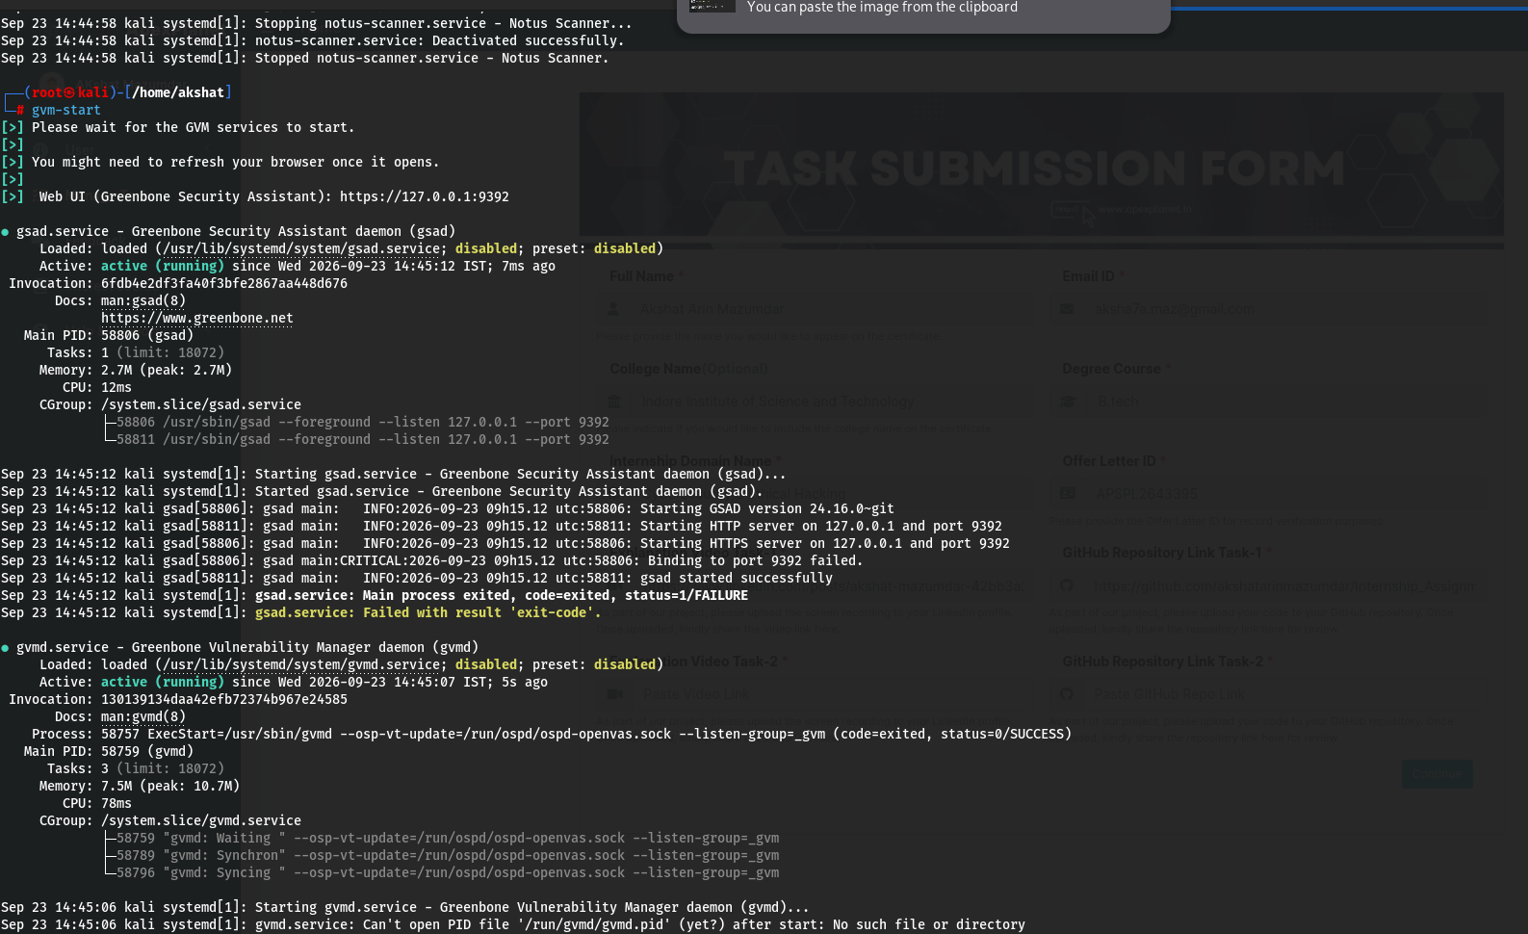
Figure 15: GVM Services Restart and Confirmation
Confirmation that the Notus scanner service was stopped and the GVM stack was restarted using gvm-start, with the Greenbone Security Assistant (gsad) and Greenbone Vulnerability Manager (gvmd) services both reporting an active (running) status, making the web-based vulnerability scanner ready for use.
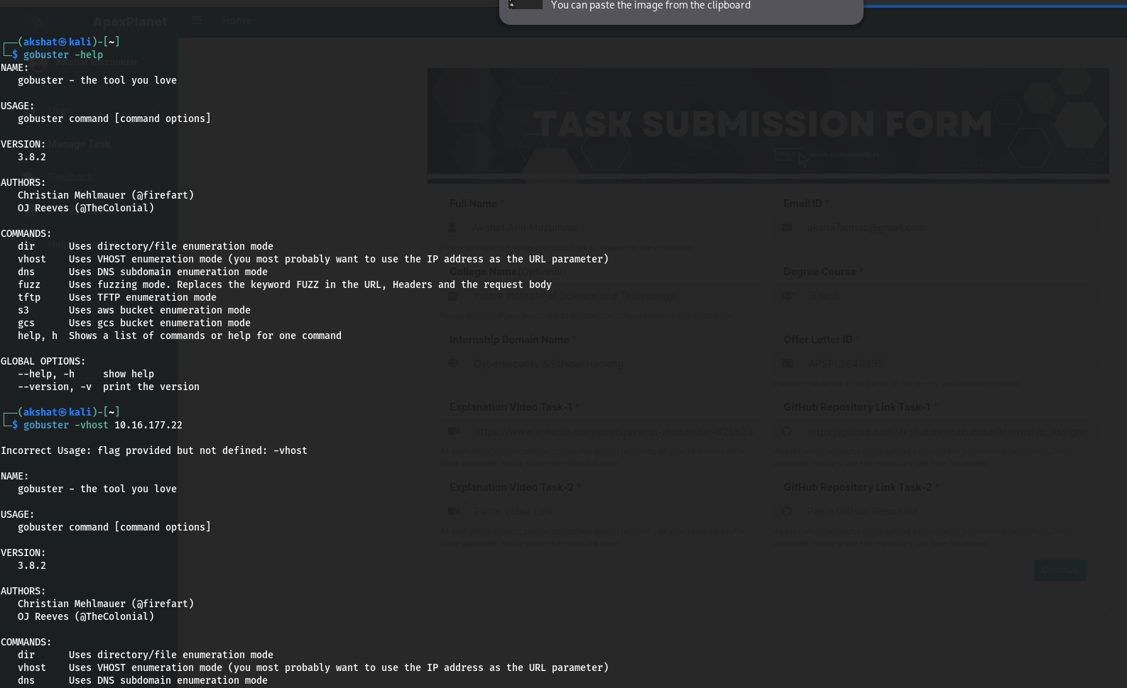
Figure 16: Gobuster Help Menu and VHOST Mode Error
The Gobuster help menu listing its available enumeration modes (dir, vhost, dns, fuzz, tftp, s3, gcs), followed by an example of an incorrect command-line flag (-vhost) being rejected, demonstrating proper command syntax verification before running a scan.
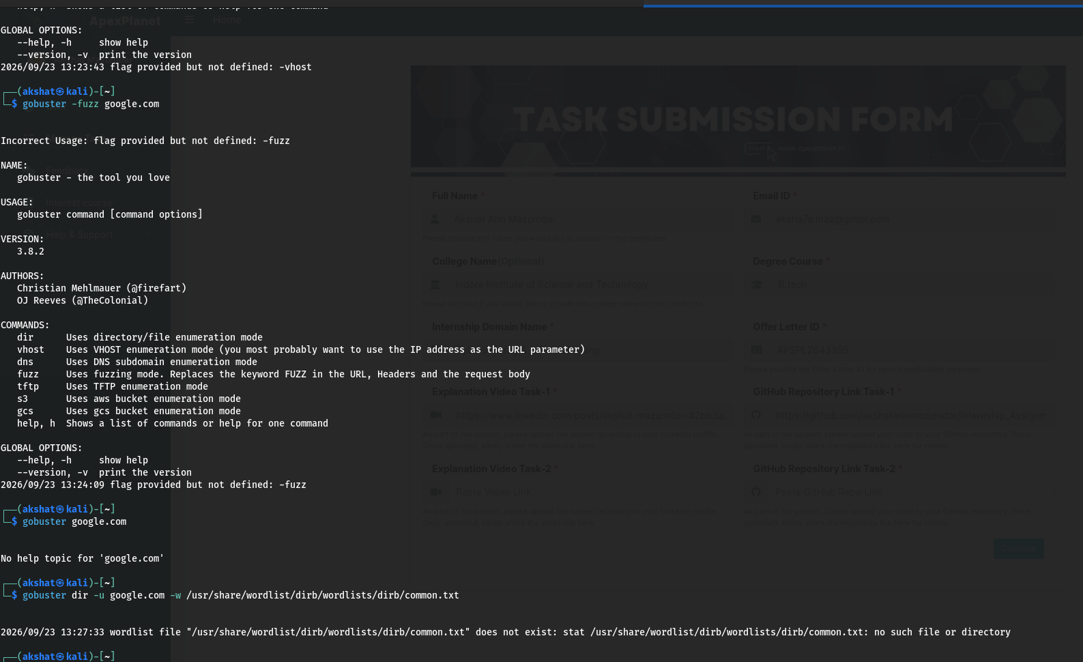
Figure 17: Gobuster Fuzzing Mode and Wordlist Path Error
An attempt to use an invalid -fuzz flag, followed by a directory scan attempt that failed because the specified wordlist path was incorrect, highlighting the importance of validating file paths (e.g., dirb/common.txt) before executing enumeration tools.
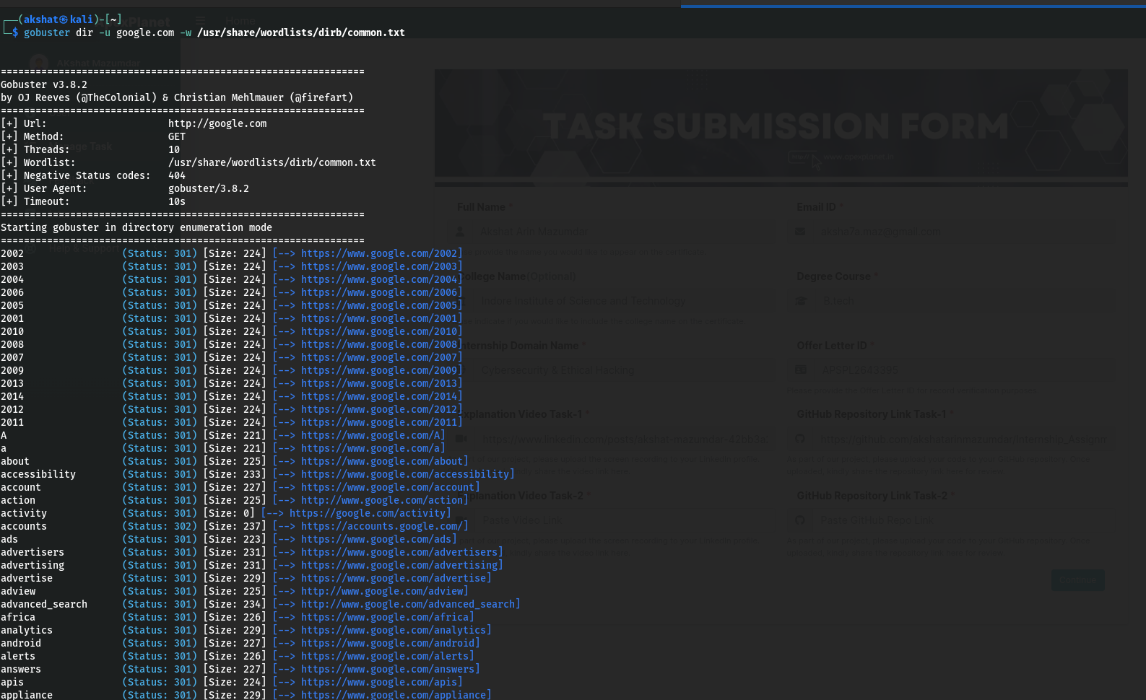
Figure 18: Gobuster Directory Scan - Successful Execution
A corrected Gobuster directory scan command using the valid wordlist path (/usr/share/wordlists/dirb/common.txt), successfully enumerating multiple valid endpoints on google.com along with their HTTP status codes and response sizes.
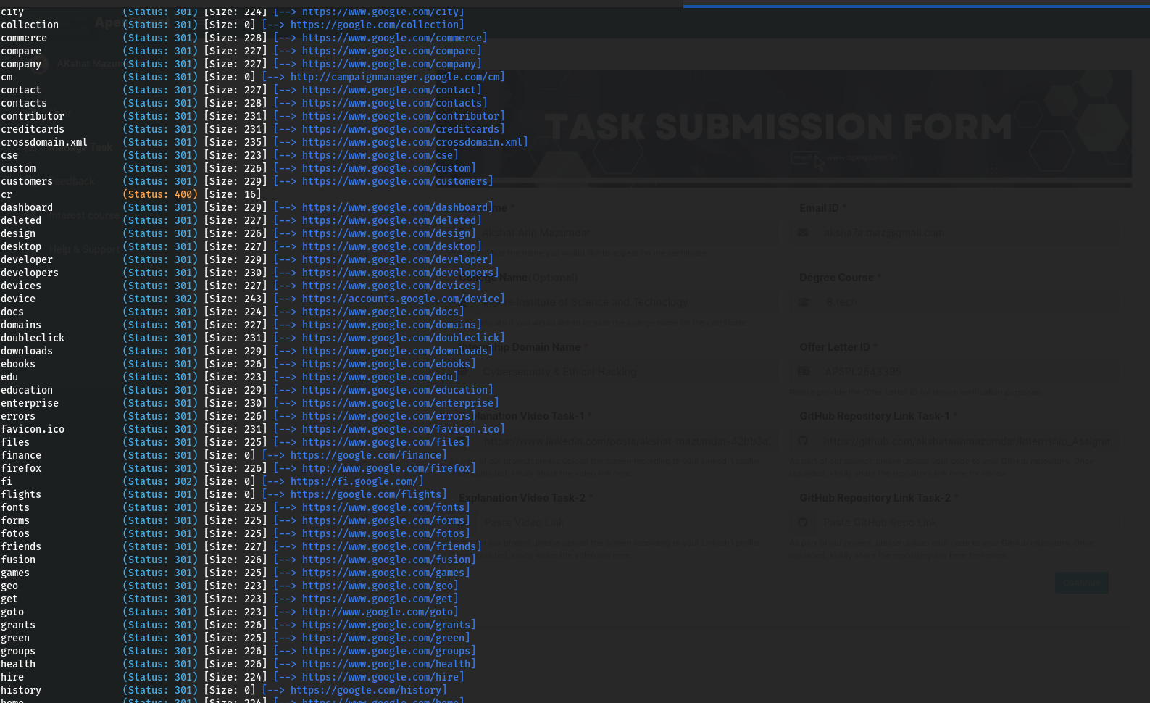
Figure 19: Gobuster Directory Scan - Extended Results
Further enumerated endpoints from the Gobuster scan (e.g., dashboard, deleted, design, devices, docs, ebooks, favicon.ico), providing a broader view of the target's directory structure and helping identify potentially interesting or sensitive paths for further investigation.

5. Conclusion / Learnings
This task provided practical, end-to-end exposure to the core stages of a network security assessment - reconnaissance, scanning, vulnerability assessment, traffic analysis, and controlled stress testing. Working with Nmap deepened the understanding of how open ports, running services, and operating systems can be fingerprinted remotely. Configuring and troubleshooting the OpenVAS/GVM stack (resolving feed locks, service failures, and authentication issues) highlighted the operational complexity behind automated vulnerability scanners and reinforced the importance of methodical debugging. Capturing traffic with Wireshark showed how packet-level visibility supports the verification of scanning and flood activity, while the hping3 SYN flood exercise illustrated, in a safe and controlled manner, how excessive SYN traffic can be generated and observed - reinforcing the rationale behind SYN-flood mitigations and firewall (iptables) filtering. Finally, the Gobuster directory enumeration exercise demonstrated how unlisted or forgotten endpoints can expose additional attack surface on a web application, and underscored the value of correct tool syntax and wordlist selection for effective enumeration.
Overall, the exercise strengthened both the technical proficiency and the analytical mindset required for ethical hacking and network security assessments, and emphasised that these tools must always be used strictly within authorised, controlled environments.

